**Final Project of TIC**

**“TIC” OR “ITC” (INFORMATION AND COMMUNICATION TECHNOLOGIES) AND THE TECHNOLOGIES RELATED**

**TO ITS.**

* KAFIF AYOUB
* ABDI ISLEM
* BOUMECHHOUR SABRINE
* CHARIF MEHDI ZOHEIR
* HAMDI SARAH

**Content table:**

**Introduction to TIC ----------------------------------------------------------- 1**

**Google services--------------------------------------------------------------- 2**

**Microsoft Tools---------------------------------------------------------------- 3**

**Git and GitHub-------------------------------------------------------- 4**

**Emerging Technologies in TIC---------------------------------- 5**

**Case Studies---------------------------------------------------------- 6**

**Future of TIC---------------------------------------------------------- 7**

**Conclusion------------------------------------------------------------ 8**

**Introduction to TIC**

﻿

**What are Information and Communication Technologies (TIC)?**

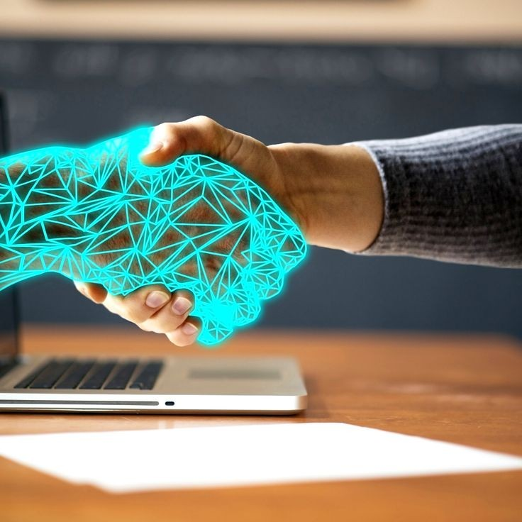Information and Communication Technologies (TIC) refer to a broad range of technologies that are used to transmit, process, store, and retrieve information. These technologies play a crucial role in the modern world, facilitating communication, data management, and access to information.

**Importance of TIC**

TIC has revolutionized various aspects of our lives, including communication, education, business, healthcare, and entertainment. Here are some key reasons why TIC is important:

* Improved Communication: TIC enables instant communication across geographical boundaries, connecting people from different parts of the world.
* Efficient Data Management: TIC allows for efficient storage, processing, and retrieval of large volumes of data, enabling organizations to make informed decisions.
* Enhanced Access to Information: TIC provides easy access to a vast amount of information, empowering individuals and organizations to acquire knowledge and stay updated.
* Increased Efficiency and Productivity: TIC automates tasks, streamlines processes, and improves productivity, saving time and resources.
* Innovation and Economic Growth: TIC drives innovation and economic growth by enabling the development of new products, services, and business models.

[1]

**Google Services**

Google offers a wide range of services that play a significant role in the field of Information and Communication Technologies (TIC). These services have revolutionized the way we access and share information, communicate with others, and collaborate on projects.

**Key Google Services:**

|  |  |  |
| --- | --- | --- |
| **Service** | **Description** | **Role in TIC** |
| **Google Search** | A web search engine that provides relevant search results based on user queries. | Enables users to access vast amounts of information and plays a crucial role in information retrieval in TIC. |
| **Gmail** | A free email service that allows users to send and receive emails. | Facilitates communication and collaboration through email, an essential component of TIC. |
| **Google Drive** | A cloud storage and file sharing service that allows users to store and access files from anywhere. | Enables seamless file sharing and collaboration, enhancing productivity and efficiency in TIC. |
| **Google Docs** | A web-based word processing application that allows users to create and edit documents collaboratively. | Promotes real-time collaboration and document sharing, facilitating teamwork and project management in TIC. |
| **Google Maps** | A web mapping service that provides detailed maps and satellite imagery. | Facilitates navigation, location-based services, and geospatial analysis, playing vital role in various TIC applications. |
| **Google Meet** | A video conferencing platform that enables virtual meetings and collaboration. | Supports remote communication and collaboration, allowing individuals and teams to connect and work together in TIC. |

[2]

**Microsoft Tools**

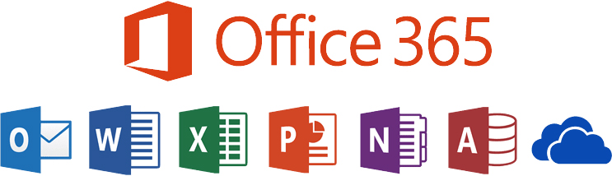

**Microsoft Azure: Microsoft Office 365:**

Microsoft Azure is a cloud computing platform Microsoft Office 365 is a suite of productivity tools

that provides a range of services for building, that includes popular applications like Word, Excel,

deploying, and managing applications and PowerPoint, and Outlook, as well as cloud

services through Microsoft-managed data services like OneDrive and SharePoint.

centers.

[3]

## Git and GitHub

Git and GitHub are essential tools in the field of Information and Communication Technologies (TIC). They revolutionize the way software development teams collaborate and manage version control.

### Microsoft planeia comprar o GitHub GitHub:

GitHub is a web-based hosting service that uses

Git for version control. It provides a platform for

developers to collaborate, share code, and

manage projects. GitHub offers features like

issue tracking, pull requests, and project

management tools.

### A Beginner's Guide to Git: All You Need To Know - 20i Git:

Git is a distributed version control system

that allows multiple developers to work

on a project simultaneously. It tracks changes,

enables branching and merging, and provides

a complete history of the project's development.

[4]

**Emerging Technologies in TIC**

**Emerging Technologies in TIC**

Artificial Intelligence (AI) is revolutionizing the

TIC industry by enabling improved automation

and decision-making processes.

**Internet of Things**

The Internet of Things (IoT) is transforming the

TIC industry by enabling enhanced connectivity

and data collection.

**Blockchain**

Blockchain technology is bringing increased security

and transparency to transactions in the TIC industry.

**Virtual Reality**

Virtual Reality (VR) is enabling immersive training and

[5] simulation experiences in the TIC industry.

**Case Studies**



### Smart City Infrastructure

Our TIC solutions have been implemented in

smart city projects, enabling efficient management

of resources, improved public safety, and enhanced

quality of life for residents.



### Connected Healthcare System

Our TIC technologies have revolutionized the healthcare

industry, enabling seamless communication and data exchange

between healthcare providers, improving patient

care and out

[6]

**Future of TIC**

### Advancements in the Field:

The future of TIC holds exciting possibilities for advancements in technology and communication.

With the rapid pace of innovation, we can expect to see:

* Increased connectivity and internet speeds, enabling faster and more reliable communication.
* Advancements in artificial intelligence and machine learning, enhancing automation and data analysis capabilities.
* Improved cybersecurity measures to protect against evolving threats and vulnerabilities.
* Integration of TIC with emerging technologies such as Internet of Things (IoT) and 5G networks.

[7]

**Conclusion**

### Key Findings :

* Information and Communication Technologies (ICT) have revolutionized the way we communicate, work, and access information.
* Emerging technologies such as Artificial Intelligence (AI), Internet of Things (IoT), and Blockchain are driving innovation and transforming industries.
* 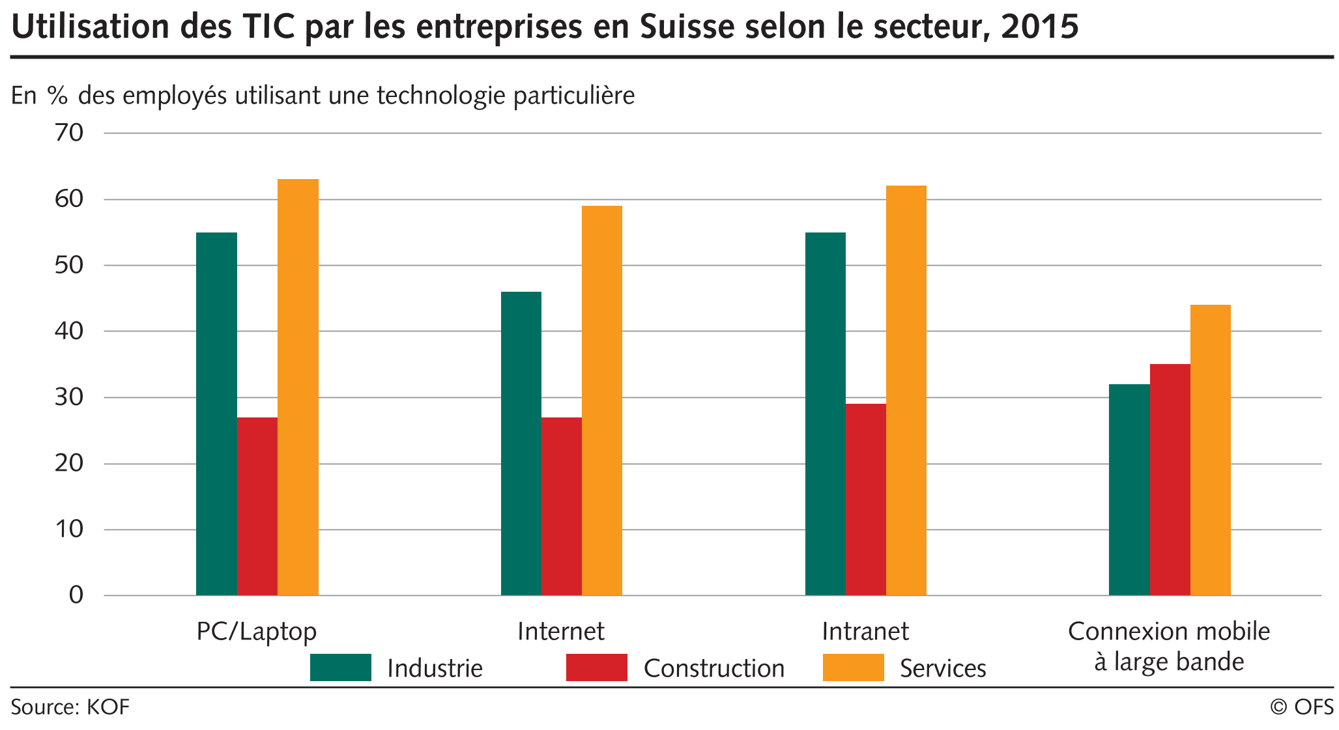ICT has enabled remote work and digital collaboration, leading to increased productivity and flexibility.

### Insights :

* The adoption of ICT is crucial for businesses to stay competitive and adapt to changing market dynamics.
* Investments in emerging technologies can lead to improved efficiency, cost savings, and new revenue streams.

[8]